(Please add this letter to your official letterhead)

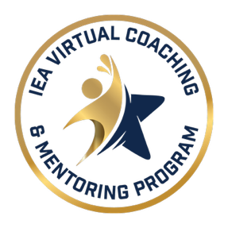


Letter of Intent
This letter is to confirm that [insert name of School District and Number] in collaboration with the [insert name of Local Association], is committed to participating in the Illinois Virtual Instructional Coach and Building Mentor Program for the 2026 - 2027 School Year.
As such, we agree to share a list of all eligible employees with the Program. We understand the Program defines eligible as teachers and clinicians who are in their 1st, 2nd, and 3rd year of practice within the state of Illinois. For the purpose of eligibility, a partial year of employment constitutes a full year of service.
`
District Local Education Association
Signature: ______________________ Signature: _______________________
Position: ______________________ President: _______________________
Date: ______________________ Date: _______________________

Please submit to:
Robyn Washington, Assistant Director of Leadership & Justice
Robyn.Washington@ieanea.org

