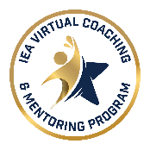

(Please add this letter to your official letterhead)
Letter of Intent

This letter is to confirm that (name of ___________School District) in collaboration with the (name of ____ Local Association), is committed to participating in the Illinois Virtual Instructional Coach and Building Mentor Program for the ________ School Year.

We anticipate the district will be hiring _____ number of first-year classroom teachers/clinicians, ____ number of second-year teachers/clinicians, and ____ number of third-year teachers/clinicians.

We understand the Program defines first-year teachers and clinicians as new hires entering their first year of certified employment.

District Local Education Association
Signature: ______________________ Signature: _______________________
Position: ______________________ President: _______________________
Date: ______________________ Date: _______________________


Submit to: Robyn Washington, Asst. Director of Leadership & Justice, at Robyn.Washington@ieanea.org

