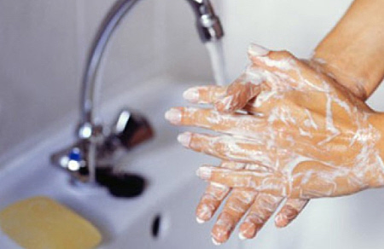

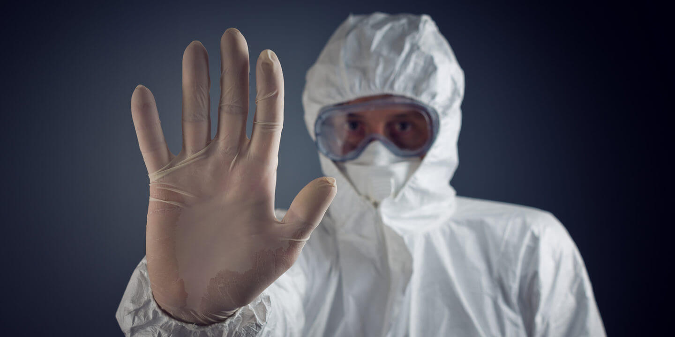

**Covid-19 and Protecting Worker Health in Illinois**



**April 9, 2020**

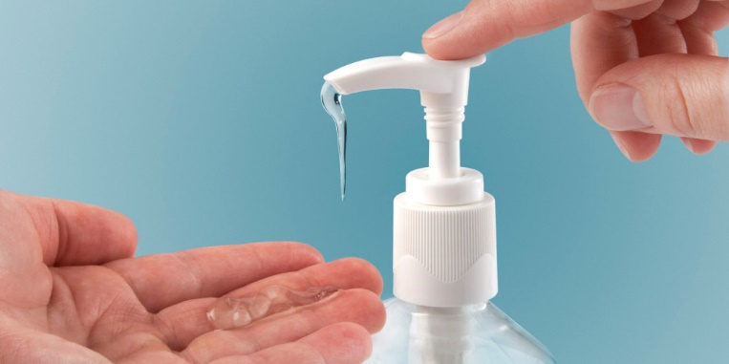

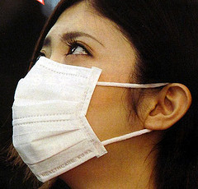

*Note: This is an aggregated list of resources that you may find helpful. While this is not a fully comprehensive*

*list about the Covid-19 Coronavirus, the information is pertinent to most people. Key points are taken*

*from teleconferences with the National Institutes of Health (NIH), National Institute of Environmental Health Sciences (NIEHS),*

*and the Midwest Consortium for Hazardous Waste Worker Training (MWC). You may find conflicting*

*information from different agencies in some situations. Use your best judgement and realize that this*

*is an ever-evolving pandemic and we are learning as we go. For broken links or suggestions for additions,*

*please contact Chris Hanson at* [*cahanson@illinois.edu*](mailto:cahanson@illinois.edu)*.*

**Chris Hanson** is the Director of the Hazardous Materials Training Program for University of Illinois. This program offers classes to provide training for government agency health and safety professionals who have hazardous materials management responsibilities. Participants from the private sector and non-management personnel are also encouraged to attend.



**Robert Bruno**, Professor and Director   
(312) 996-2491 [bbruno@illinois.edu](mailto:bbruno@illinois.edu)

**Allison Frees-Williams**, Assistant Director   
(217) 300-7667  
[allisonf@illinois.edu](mailto:allisonf@illinois.edu)

**Key Points:**

* **Keep hydrated** – Reduces mucus and helps with proper distribution of medication if you get sick. Chinese autopsies showed that many of the victims were severely dehydrated and therefore not able to fully absorb medications.
* **Exercise** – Studies show that sedentary people cannot effectively fight infections because their white blood cells tend to pool in the extremities. Exercise helps keep them moving throughout the body and makes them more effective as hunter-killers.
* **Asthma and Allergy Sufferers** – Ensure you keep medicated.
* **Tylenol** - Use for fever.
* **Ibuprofen** – Use for muscle aches.
* **Masks** – People who want to wear masks should understand that they are being recommended primarily to reduce the transmission of aerosols from coughing and sneezing. Unless you have been fit tested, and are wearing an N95 mask properly, you will see limited protection from the Coronavirus.
* **Hierarchy of Protection** – N95 masks offer the most protection, followed by surgical masks, and cloth masks or scarves are only really going to limit aerosols that the sick expel when coughing and sneezing.



* **Virus Transmission** – Most of the infected are getting the Coronavirus from touching an infected surface and then touching their face, eyes or mouth. Social distancing reduces the risk of exposure to airborne aerosols.
* Since the outer layer of the virus is sticky, contamination can be found in peaks and valleys of isolation gowns or outer clothing. Take regular showers and make sure to wash hair frequently.
* **Laundry** – Follow CDC guidelines here: <https://www.cdc.gov/coronavirus/2019-ncov/hcp/guidance-prevent-spread.html>
* **Homemade Hand Sanitizers** – Alcohol content should be 60% or higher for ethanol and 70% or higher for Isopropyl Alcohol per FDA guidance. Most spirits such as Vodka typically have 40% alcohol (80 proof). <https://www.regulations.gov/document?D=FDA-2020-D-1106-0016> refer to paragraph I.
* **Soaps and Hand Sanitizers** break down the outer lipid layer of the virus. Wash hands at least 20 seconds.
* **Re-using Masks** – When donning (putting on) and doffing (taking off), only touch the outside of the mask to prevent cross contamination to the inside which must stay clean.
* **Facial Hair and Respirators** – Facial hair that lies beneath the sealing area of a mask can cause 20 – 1000 times more leakage compared to clean shaven individuals. An alternative to wearers unwilling or unable to shave would be Powered Air Purifying Respirator (PAPR) with hood or helmet. Most will not have access to PAPRs, therefore clean shaven beneath the sealing area is the only way to ensure that a mask will provide adequate protection. <https://blogs.cdc.gov/niosh-science-blog/2020/04/01/fit-testing-during-outbreaks/?deliveryName=USCDC_170-DM24662>. Below is a chart of facial hairstyles that may be compatible with a respirator or mask.
* **\* Daily News** – Avoid watching too much news and getting inundated, depressed, and overwhelmed with information. Some news has been sensationalized and other sources are sometimes wrong or the information is already out of date. Refer to these resources frequently for the most current information.



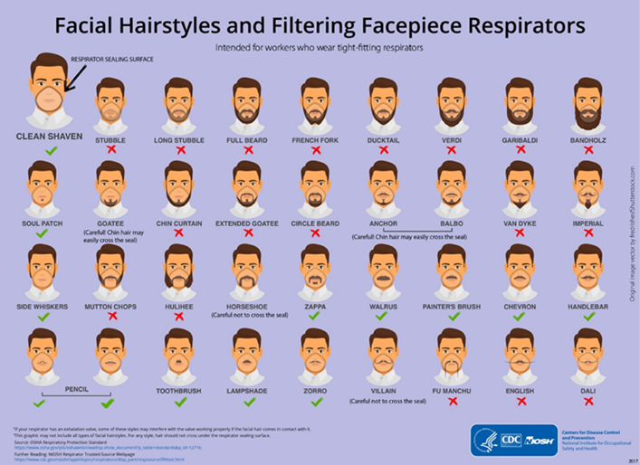

**Resources:**

NIEHS (National Institute of Environmental Health Sciences) COVID-19 Presentation

<https://tools.niehs.nih.gov/wetp/public/hasl_get_blob.cfm?ID=11781>

Gryphon Scientific COVID-19 Presentation

<https://www.gryphonscientific.com/wp-content/uploads/2020/03/COVID-19-Presentation-17-March-2019-1.pdf>

CDC (Centers for Disease Control) Coronavirus Information

<https://www.cdc.gov/coronavirus/2019-ncov/index.html>

CDC Coronavirus Factsheet #1

<https://www.cdc.gov/coronavirus/2019-ncov/downloads/2019-ncov-factsheet.pdf>

CDC Coronavirus Factsheet #2

<https://www.cdc.gov/coronavirus/2019-ncov/about/share-facts-h.pdf>

CDC Situation Summary

<https://www.cdc.gov/coronavirus/2019-ncov/cases-updates/summary.html?CDC_AA_refVal=https%3A%2F%2Fwww.cdc.gov%2Fcoronavirus%2F2019-ncov%2Fsummary.html>

CDC – Preventing COVID-19 Spread in Schools, Workplaces and Communities

<https://www.cdc.gov/coronavirus/2019-ncov/community/index.html>

CDC - Interim Guidance for Businesses and Employers

<https://www.cdc.gov/coronavirus/2019-ncov/community/guidance-business-response.html?CDC_AA_refVal=https%3A%2F%2Fwww.cdc.gov%2Fcoronavirus%2F2019-ncov%2Fspecific-groups%2Fguidance-business-response.html>



CDC – Interim Guidance for Patients with Suspected or Confirmed COVID-19

<https://www.cdc.gov/coronavirus/2019-ncov/infection-control/control-recommendations.html?CDC_AA_refVal=https%3A%2F%2Fwww.cdc.gov%2Fcoronavirus%2F2019-ncov%2Fhcp%2Finfection-control.html>

CDC – Frequently Asked Questions

<https://www.cdc.gov/coronavirus/2019-ncov/faq.html>

NIOSH (National Institute for Occupational Safety and Health) COVID-19 Resource Page

<https://www.cdc.gov/niosh/emres/2019_ncov.html>

NIH (National Institutes of Health) COVID-19 Resource Page

<https://www.nih.gov/health-information/coronavirus>

NIAID (National Institute of Allergy and Infectious Diseases) COVID-19 Resource Page

<https://www.niaid.nih.gov/diseases-conditions/coronaviruses>

OSHA (Occupational Safety and Health Administration) COVID-19 Workplace Safety Guidance

<https://www.osha.gov/Publications/OSHA3990.pdf>

OSHA – Protecting Workers during a Pandemic

<https://www.osha.gov/Publications/OSHAFS-3747.pdf>

OSHA – Information for Workers and Employers

<https://www.osha.gov/SLTC/covid-19/>

DOL (Department of Labor) Coronavirus Resource Page

<https://www.dol.gov/coronavirus>

DOL – COVID-19 and the American Workplace

<https://www.dol.gov/agencies/whd/pandemic>

DOL – Paid Sick Leave and Expanded Family and Medical Leave under the Coronavirus Response Act

<https://www.dol.gov/newsroom/releases/whd/whd20200324>

EPA Coronavirus Resource Page

<https://www.epa.gov/coronavirus>

WHO (World Health Organization) COVID-19 Resource Page

<https://www.who.int/health-topics/coronavirus#tab=tab_1>

NLM (National Library of Medicine) COVID-19 Resource Page

<https://www.nlm.nih.gov/index.html#Novel_Coronavirus>

University of Minnesota – Center for infectious Disease Research and Policy

<http://www.cidrap.umn.edu/covid-19>

Johns Hopkins – Coronavirus Map

<https://coronavirus.jhu.edu/map.html>

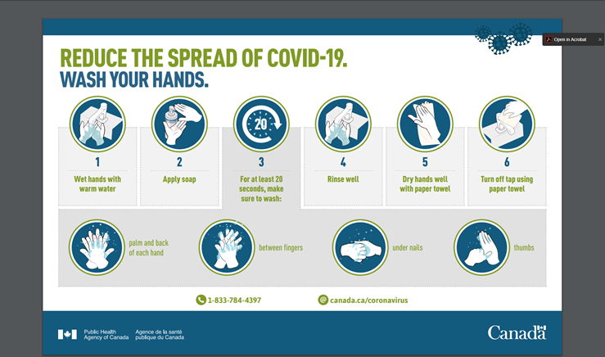



**Disinfectant Information:**

EPA - (Environmental Protection Agency) List N: Disinfectants for Use Against COVID-19

<https://www.epa.gov/pesticide-registration/list-n-disinfectants-use-against-sars-cov-2>

CDC - Environmental Cleaning and Disinfection Recommendations

<https://www.cdc.gov/coronavirus/2019-ncov/community/organizations/cleaning-disinfection.html>

CDC – Cleaning and Disinfection for Households

<https://www.cdc.gov/coronavirus/2019-ncov/prevent-getting-sick/cleaning-disinfection.html?CDC_AA_refVal=https%3A%2F%2Fwww.cdc.gov%2Fcoronavirus%2F2019-ncov%2Fprepare%2Fcleaning-disinfection.html>

*Chemical and Engineering News*, “How we know disinfectants should kill the COVID-19 coronavirus”:

<https://cen.acs.org/biological-chemistry/infectious-disease/How-we-know-disinfectants-should-kill-the-COVID-19-coronavirus/98/web/2020/03?utm_source=Newsletter&utm_medium=Newsletter&utm_campaign=CEN>

New York State Registered Disinfectants Based on EPA List

<https://www.dec.ny.gov/docs/materials_minerals_pdf/covid19.pdf>

National Pesticide Information Center (NPIC)

<http://npic.orst.edu/ingred/ptype/amicrob/covid19.html>

Center for Biocide Chemistries

<https://www.americanchemistry.com/Novel-Coronavirus-Fighting-Products-List.pdf>

**Respirator Information:**

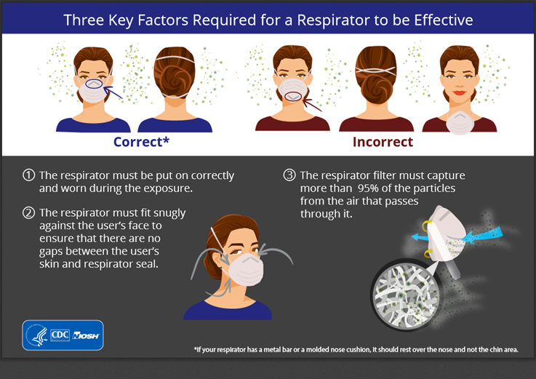

CDC - 3 Key Factors for a Respirator to be Effective

<https://www.cdc.gov/niosh/npptl/pdfs/KeyFactorsRequiedResp01042018-508.pdf>

CDC – How to Properly Put on and Take off a Disposable Respirator

<https://www.cdc.gov/niosh/docs/2010-131/pdfs/2010-131.pdf?id=10.26616/NIOSHPUB2010131>

CDC – Frequently Asked Questions about Personal Protective Equipment (PPE)

<https://www.cdc.gov/coronavirus/2019-ncov/hcp/respirator-use-faq.html>



CDC-Correct Donning and Doffing

<https://www.cdc.gov/niosh/docs/2010-133/pdfs/2010-133.pdf>

CDC- Recommended Guidance for Extended and Limited Re-use of N95 Masks

<https://www.cdc.gov/niosh/topics/hcwcontrols/recommendedguidanceextuse.html>

NIOSH – Sequence for Putting On Personal Protective Equipment

<https://www.cdc.gov/niosh/npptl/pdfs/PPE-Sequence-508.pdf>

Handwashing Infographic from Canada

<https://www.canada.ca/content/dam/phac-aspc/documents/services/publications/diseases-conditions/coronavirus/covid-19-handwashing/covid-19-handwashing-eng.pdf>

Social Distancing Infographic from Fairfax County, VA

<https://www.fairfaxcounty.gov/covid19/sites/covid19/files/Assets/images/social-distance-english.png>

Coronavirus and Masks

<https://www.knoxnews.com/story/news/2020/03/11/coronavirus-masks-n-95-respirators-faq/4978243002/>

AFL – CIO

<https://aflcio.org/sites/default/files/2020-03/Action%20to%20Address%20the%20Shortage%20of%20%20Respirators%20and%20Facemasks%20for%20COVID%20Final.pdf>

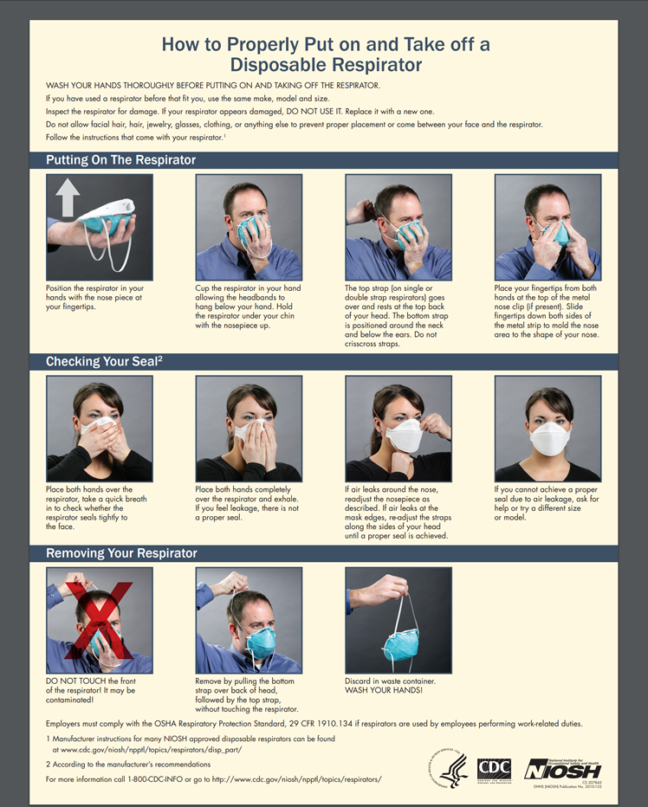

**Graphics:**

[**https://www.cdc.gov/niosh/npptl/pdfs/KeyFactorsRequiedResp01042018-508.pdf**](https://www.cdc.gov/niosh/npptl/pdfs/KeyFactorsRequiedResp01042018-508.pdf)



**COVID-19 Articles:**

New York Times:

<https://www.nytimes.com/interactive/2020/03/15/business/economy/coronavirus-worker-risk.html?action=click&module=Top%20Stories&pgtype=Homepage>

New York Times Article on Coronavirus Risk by Occupation

<https://www.nytimes.com/interactive/2020/03/15/business/economy/coronavirus-worker-risk.html?action=click&module=Top%20Stories&pgtype=Homepage>

Seattle Times:

<https://assets.documentcloud.org/documents/6796908/Seattle-Times-Coronavirus-Fact-Sheet.pdf>

**COVID-19 Multimedia:**

WHO – eProtect Respiratory Infections

<https://openwho.org/courses/eprotect-acute-respiratory-infections>

CDC – COVID-19

<https://www.youtube.com/watch?v=kIL5m5XznNY>

NPR – The Splendid Table: Good information on food safety and cooking ideas during the Covid-19 Pandemic

<https://www.npr.org/podcasts/381444592/the-splendid-table>

*If there is an interest in virtual classes on worker health and safety during this pandemic please reach out to:*

*Chris Hansan (217)333-0640,* [*cahanson@illinois.edu*](mailto:cahanson@illinois.edu)

*Bob Bruno (312)996-2491, bbruno@illinois.edu*

*Allison Frees-Williams (217)300-7667, allisonf@illinois.edu*