IEA Online Learning Portal Login Instructions
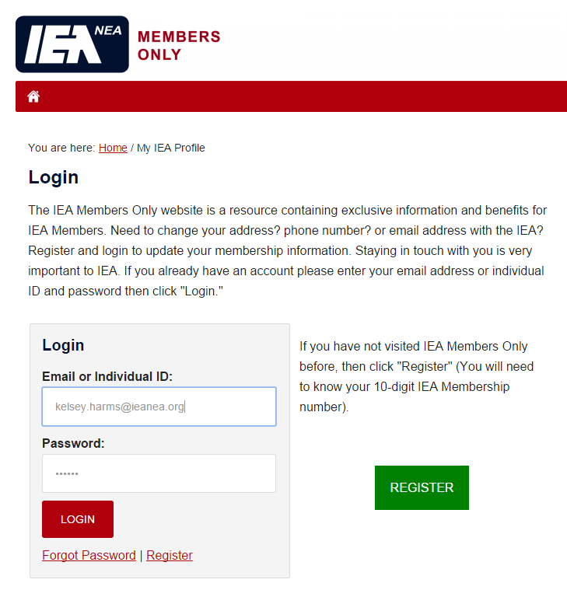
- Signing into the IEA Online Learning Portal is easier than ever! Sign into Members Only: https://member.ieanea.org/login.aspx
- If you have not yet registered for an account, you will need your 10-digit individual ID number to do so.

- Click on the IEA Online Learning Portal link. The IEA Connect Live Chat feature is now available on the course homepage as well!
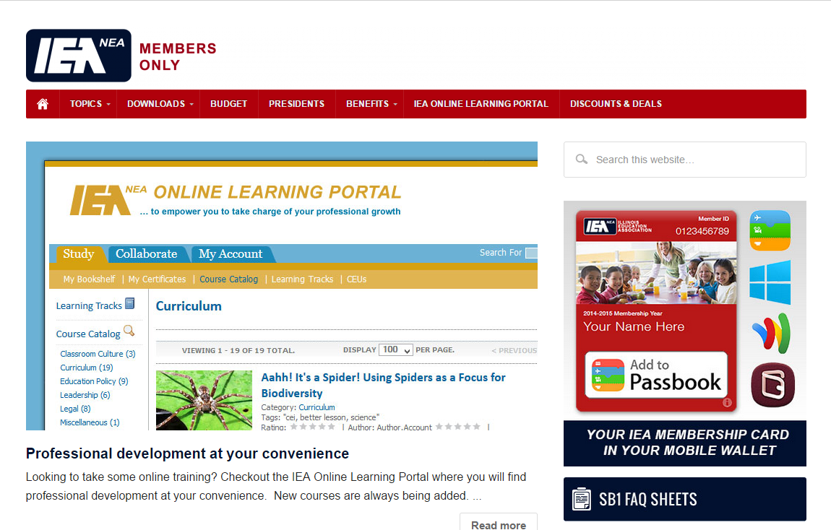
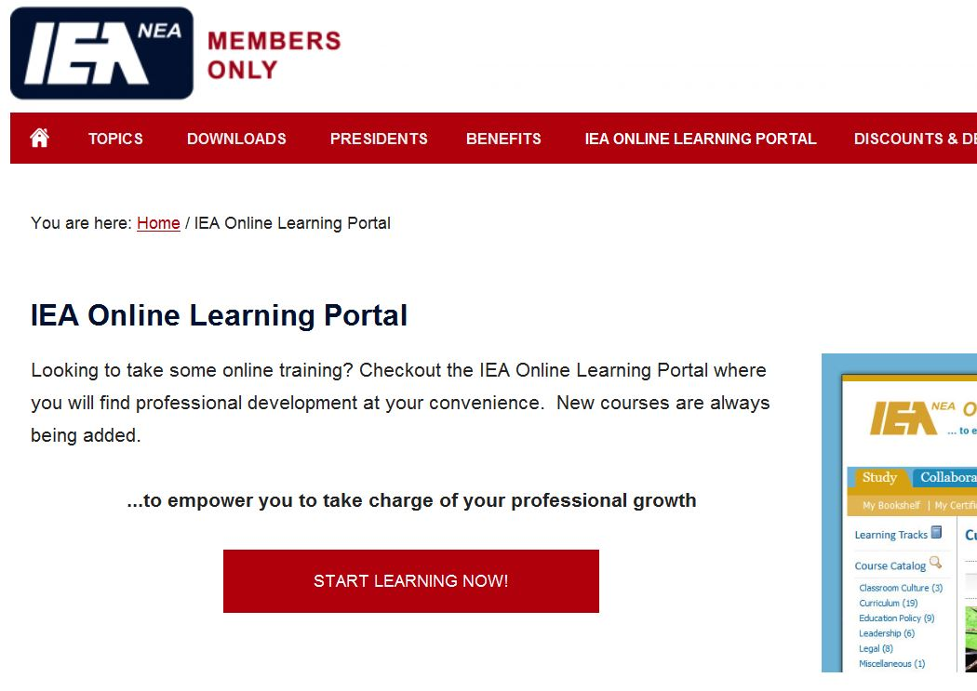
- Click Start Learning Now!

- A new window will open. Click on Miscellaneous under Course Catalog on the left or type Degrees Not Debt into the Search bar at the top right.
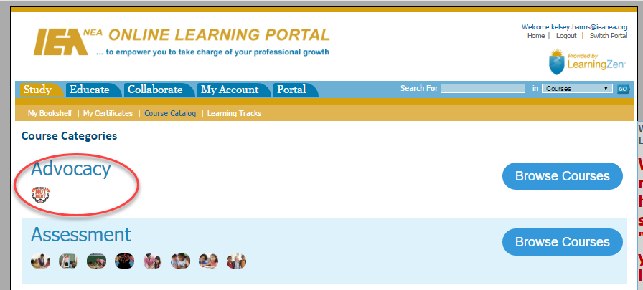

- Click Take Course! Be sure to browse the other topics and training materials that are available on the Online Learning Portal!

