IEA Promotional Items
To place an order, please complete and mail the order form,
or call Nicole Gerberding at 217-321-2219, email nicole.gerberding@ieanea.org
Revised 07/2016
 | Item | Unit Price | Quantity | Color or Year | Total cost
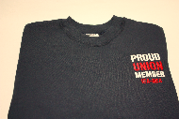 | NEW!! IEA Proud Union Member Sweatshirt  Navy blue with white and red embroidery. 80/20 cotton blend.  MADE IN THE USA  Sizes Small – 3XL | $30.00 |  | Size
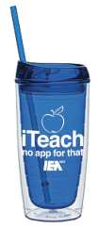 | ‘iTeach no app for that’ travel mug | $5.00
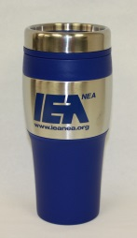 | Stainless steel travel mug | $5.00
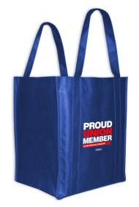 | IEA tote | $3.00
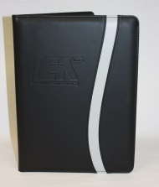 | Soft Vinyl Portfolio  Black and silver w/IEA logo  Includes 8 ½ X 11 pad of paper | $10.00
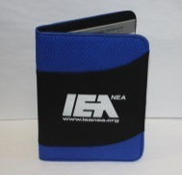 | Small Portfolio  Blue and black w/IEA logo  Includes 5 X 8 pad of paper | $5.00

 | Item | Unit Price | Quantity | Color or Year | Total cost
 | NEW!!  IEA Leather Luggage Tag with business card window. | $5.00
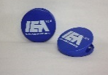 | NEW!!  IEA Big Clip with magnet | $2.50
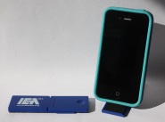 | IEA Cell Phone stand w/cleaner | $2.00
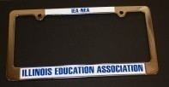 | IEA License Plate Frame | $10.00  $5.00
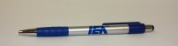 | IEA Stylus Pen with screen wipe | $1.50
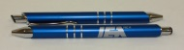 | IEA Silver click pen | $1.50
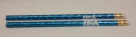 | IEA Blue Pencil | $ .50
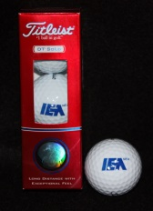 | IEA Logo Golf Balls  sleeve of three | $6.00
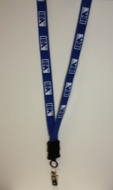 | IEA lanyard - Blue w/white logo | $4.00  $3.00
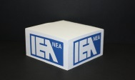 | IEA Note Cube | $4.00
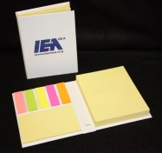 | Post It Note Booklet | $4.00

 | Item | Unit Price | Quantity | Color or Year | Total cost
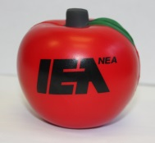 | Apple Stress Grip | $2.50
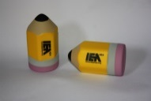 | Pencil Stress Grip | $2.50
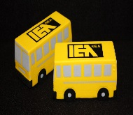 | School Bus Stress Grip | $2.50
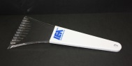 | Ice Scraper White w/blue IEA Logo | $ 2.50
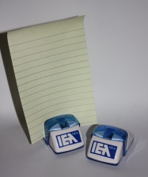 | Docu-Stand Document Holder | $2.00
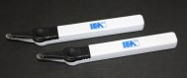 | Staple Puller  White w/blue IEA Logo | $ 1.50
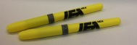 | Brite Liner Highlighter - w/IEA Logo Yellow | $ 1.00
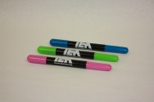 | No Dry Gel Highlighters | $ 1.00 |  | Color(s)
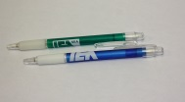 | Kool Klick Mechanical Pencil - Red, Green or Blue | $ 1.00
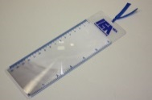 | IEA Magnifying Bookmark | $1.00  $ .50

 | Item | Unit Price | Quantity | Color or Year | Total cost
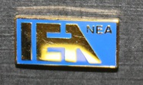 | IEA-NEA Logo Lapel Pin | $ 3.00
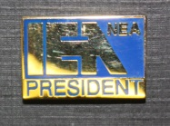 | IEA-NEA Logo Lapel Pin – President | $ 3.00
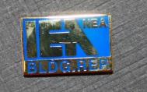 | IEA-NEA Logo Lapel Pin – Bldg. Rep. | $ 3.00
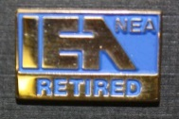 | IEA-NEA Logo Lapel Pin – Retired | $ 3.00
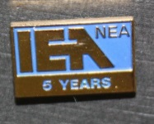 | IEA-NEA Logo Lapel Pin - 5, 10, 15, 20, 25, 30 years | $ 3.00 |  | Year(s)?

To purchase, complete an order form and mail or fax to:

Nicole Gerberding Phone: 217-321-2219
IEA Membership Processing Email: nicole.gerberding@ieanea.org
100 East Edwards

Springfield, Illinois 62704

No shipping charge if ordered using this form.

Make checks payable to the Illinois Education Association.

Please complete:

Person ordering materials: ______________________________________

Shipping address: ___________________________________________________________
___________________________________________________________
___________________________________________________________

Daytime phone: _______________________________________________

Email address *: _______________________________________________

* this information is optional

THANK YOU!

